**Assignment Topic**:- **Interactive and Non-Interactive Applications , Intunewin conversion - Compatible version to upload to Intune, Process Flow for an Application on Windows client via IME service. (From Polling to detection, to installation , to detection and toast notifications as success/failure), Registries with respect to LOB and Win32Apps**

**E-mail ID:-** innamaf29@gmail.com

**Name**:- Batool Fatima

**User ID**:- 34723

**Interactive and Non-Interactive Applications**

Interactive applications are programs that need you to use them — like clicking, typing, or choosing from menus. They usually have a screen you can see and interact with, such as web browsers, games, or media players. Non-interactive applications work quietly in the background without needing your help. They don’t have a visible screen and handle tasks like updating software, scanning for viruses, or managing network connections. These are often called services or background processes. In simple terms, interactive apps need you to work, while non-interactive ones do their job on their own without bothering you.

**Intunewin conversion - Compatible version to upload to Intune**

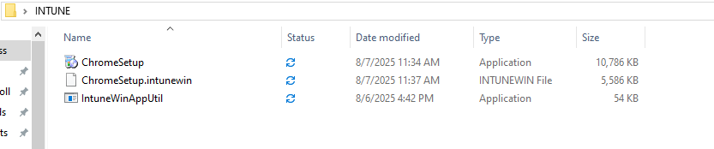

To deploy a Win32 app using Intune, first collect all the installation files for your application. Then use the Microsoft Win32 Content Prep Tool, which is named IntuneWinAppUtil.exe. Open Command Prompt and run the tool — it will guide you through packaging your files into a .intunewin file. Once created, go to the Intune admin center, add a new Windows app (Win32), and upload the .intunewin file. You’ll need to enter the silent install and uninstall commands. Make sure the app size is under 8 GB, and your devices are running Windows 10 version 1607 or later and are enrolled in Intune.

**Process Flow for an Application on Windows client via IME service. (From Polling to detection, to installation , to detection and toast notifications as success/failure)**

The Intune Management Extension service helps install apps on Windows devices through a step-by-step process. First, the device regularly checks (polls) Intune for new apps. Then it checks if the app is already installed using detection rules. If not found, the app is downloaded, unpacked, and installed using the command provided by the admin. After installation, detection rules run again to confirm success. The user sees a toast notification showing whether the app was installed successfully or not. If needed, the device may restart to apply changes based on Intune settings.

**Registries with respect to LOB and Win32Apps**

In Intune, both Line-of-Business (LOB) and Win32 apps can use the Windows Registry to store and manage settings. The registry is a system database where Windows and apps keep configuration data, like install status, user preferences, or behavior settings. Intune uses registry keys to detect whether an app is already installed or to apply specific configurations. LOB apps (custom-built for organizations) and traditional Win32 apps both rely on these registry entries. Since the registry controls critical system and app behavior, any changes to it should be done carefully to avoid problems.